|  |  |  |  |  |
| --- | --- | --- | --- | --- |
| |  | | --- | |  | |  | |  | |  | |
| TiltBot  Interactive maze-solving entertainment device. |
| FINAL SPRINT DATE: 12 June 2024  Jaime Martinez Coca - 1634495 Robert Pearson Ruiz - 1630916  Sergio López Parejo - 1634093  David Fuentes Insa - 1637892 |

Table of Contents

Project description 1

Electronic components 1

Scheme 1

Extra components and 3D pieces 1

Foreseen risks and contingency plan 2

TiltBot

Interactive maze-solving entertainment device.

# Project description

TiltBot is an entertainment device where you try to get a ball from one side of a maze to the opposite side, just by tilting it. Along the way, you'll need to dodge holes, or you'll have to start over! Using it is simple: you can tilt the maze platform where the ball is located with a joystick.

If crossing the maze is too difficult, TiltBot has an extra feature. You can switch to an automatic mode, where AI will solve the maze, showing you one of the possible paths to the end. (For now, the algorithm is somewhat limited. See the Limitations section.)

Additionally, to increase the amount of fun, the maze format can be customized. You can open or close holes, as well as restructure the walls to choose your own difficulty.

# Electronic components

This is the list of the used components:

* *Arduino UNO R3*
* *Raspberrypi 3B+*
* *Joystick*
* *x2 Microservo*
* *Camera Raspberrypi v2*

# Action Module

This module is the one in charge of the actual movement of the labyrinth that allows the puzzle to be solved.

Action Hardware

In order to move the structure, we make use of two different servo motors, one for the outer layer, and the other for the inner layer. Each of these servos move in different directions, allowing the structure to tilt in any angle needed. For a deeper understanding check Structure.

To be able to control manually these servos we have also connected a joystick, which moves both motors accordingly to the direction and amount of pressure applied on it.

All of this is interconnected by an Arduino UNO R3 module.

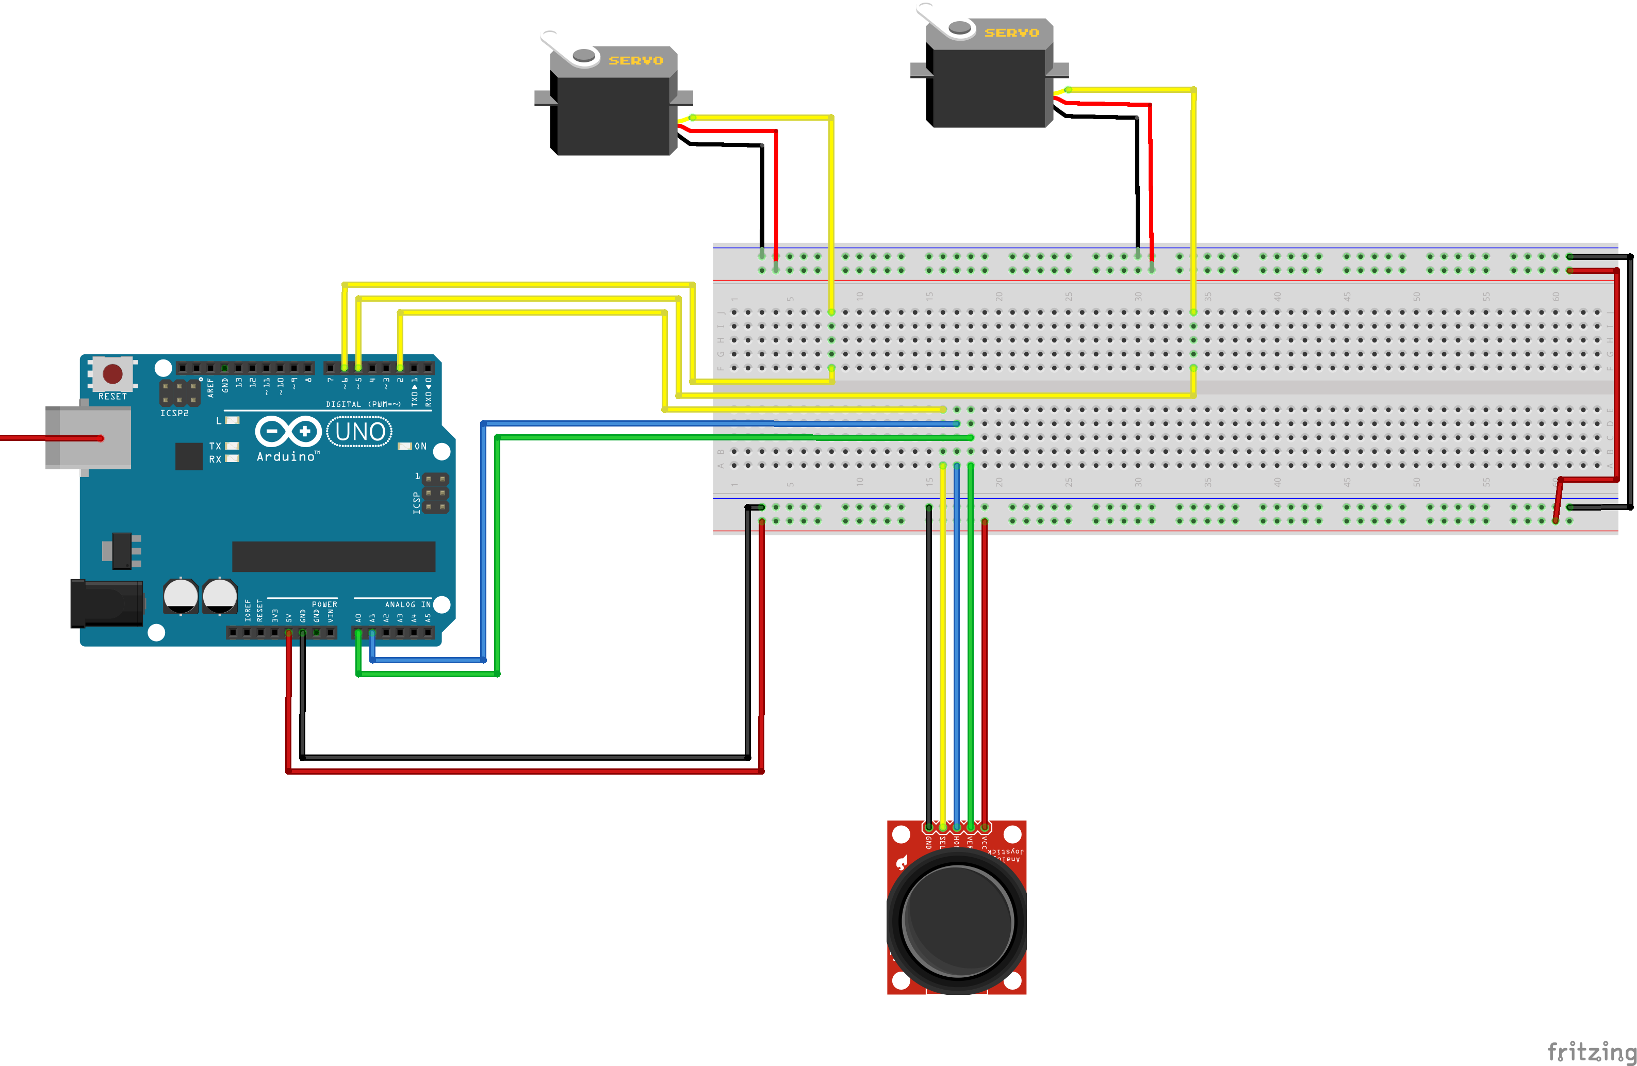

* *Servo_1 SEL is connected to digital pin 6*
* *Servo_2 SEL is connected to digital pin 5*
* *Joystick SEL is connected to digital pin 2*
* *Joystick VER is connected to digital pin A0*
* *Joystick HOR is connected to digital pin A1*

Action Software

# Vision Module

The vision module is responsible for the automated maze-solving part. When requested, it will take a photograph of the maze from above and find a path from a starting point to an endpoint. It will then give instructions to the action module to try to move the ball along the path.

Vision Hardware

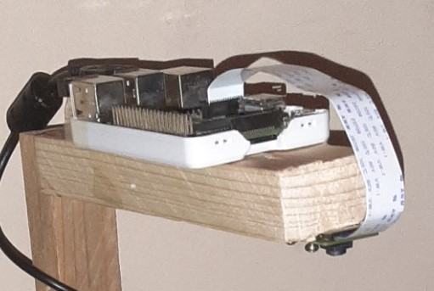The hardware part is very simple. It consists of a Raspberry Pi 3B+ connected to a camera positioned above the center of the maze, and also connected to an Arduino UNO R3.

Vision Software

To work with images, we use the OpenCV library and Numpy to handle the structures. Then, for the connection between the Raspberry Pi and the Arduino, we use the serial library along with the json library for sending information.

# Structure

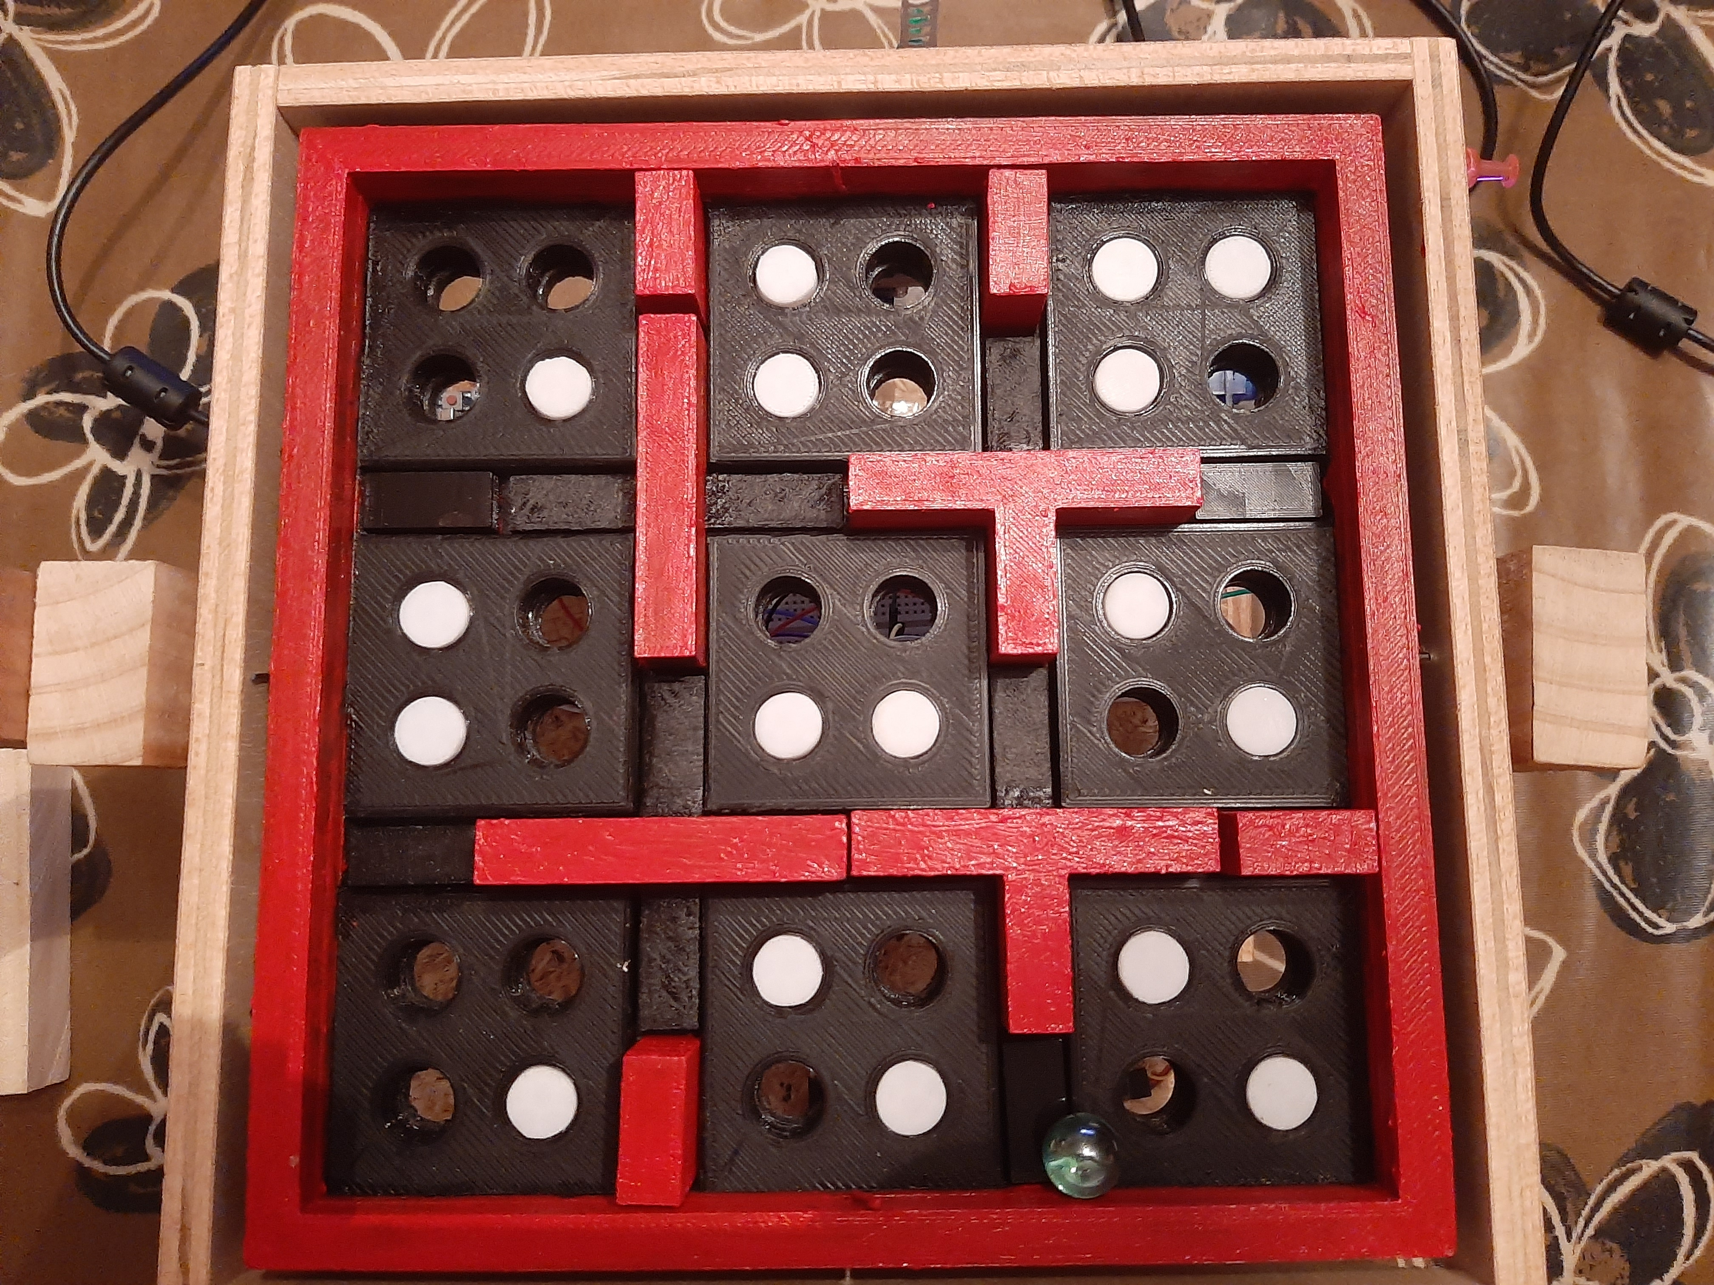The structure is one of the most important parts of this project. To create a customizable maze, we had to come up with a structure that would allow us to rearrange where the walls that delimit the path of the maze should be, and the holes through which it should avoid falling. We designed the platform of our maze with holes where different pieces of walls fit and holes where plugs fit that allow the ball to pass over it. In addition to this, the structure has an exterior frame that will allow the platform to rotate on an axis. This has been achieved by means of a servomotor that will be attached to this frame by means of an elongated metal plate. As for the movement in the other axis of the inner platform, we have placed another servo attached to the bottom of the inner platform of the maze and joined to the outer frame by another plate. This allows us to obtain the desired movement in both axes.

Extra components and 3D pieces

* Labyrinth base
* Plugs
* x4 exterior walls
* x4 exterior floor pieces
* x2 cross shaped walls
* x2 T shaped walls
* x2 I shaped walls

- We made a platform that has nine main isles of floor. Among them, four central X-shaped holes remain in the center of the platform, and eight small holes are located on the exterior side. Also, each piece of the floor has four holes in it, that can be fitted with our plugs in order to make the maze either easier or harder.

- Regarding the plugs, they are all the same, and they are of such a height that allows the ball to pass over it effortlessly. These plugs allow us to change the location of the holes, as well as modifying the difficulty of the maze, increasing or decreasing the number of wholes through which the ball can fall through.

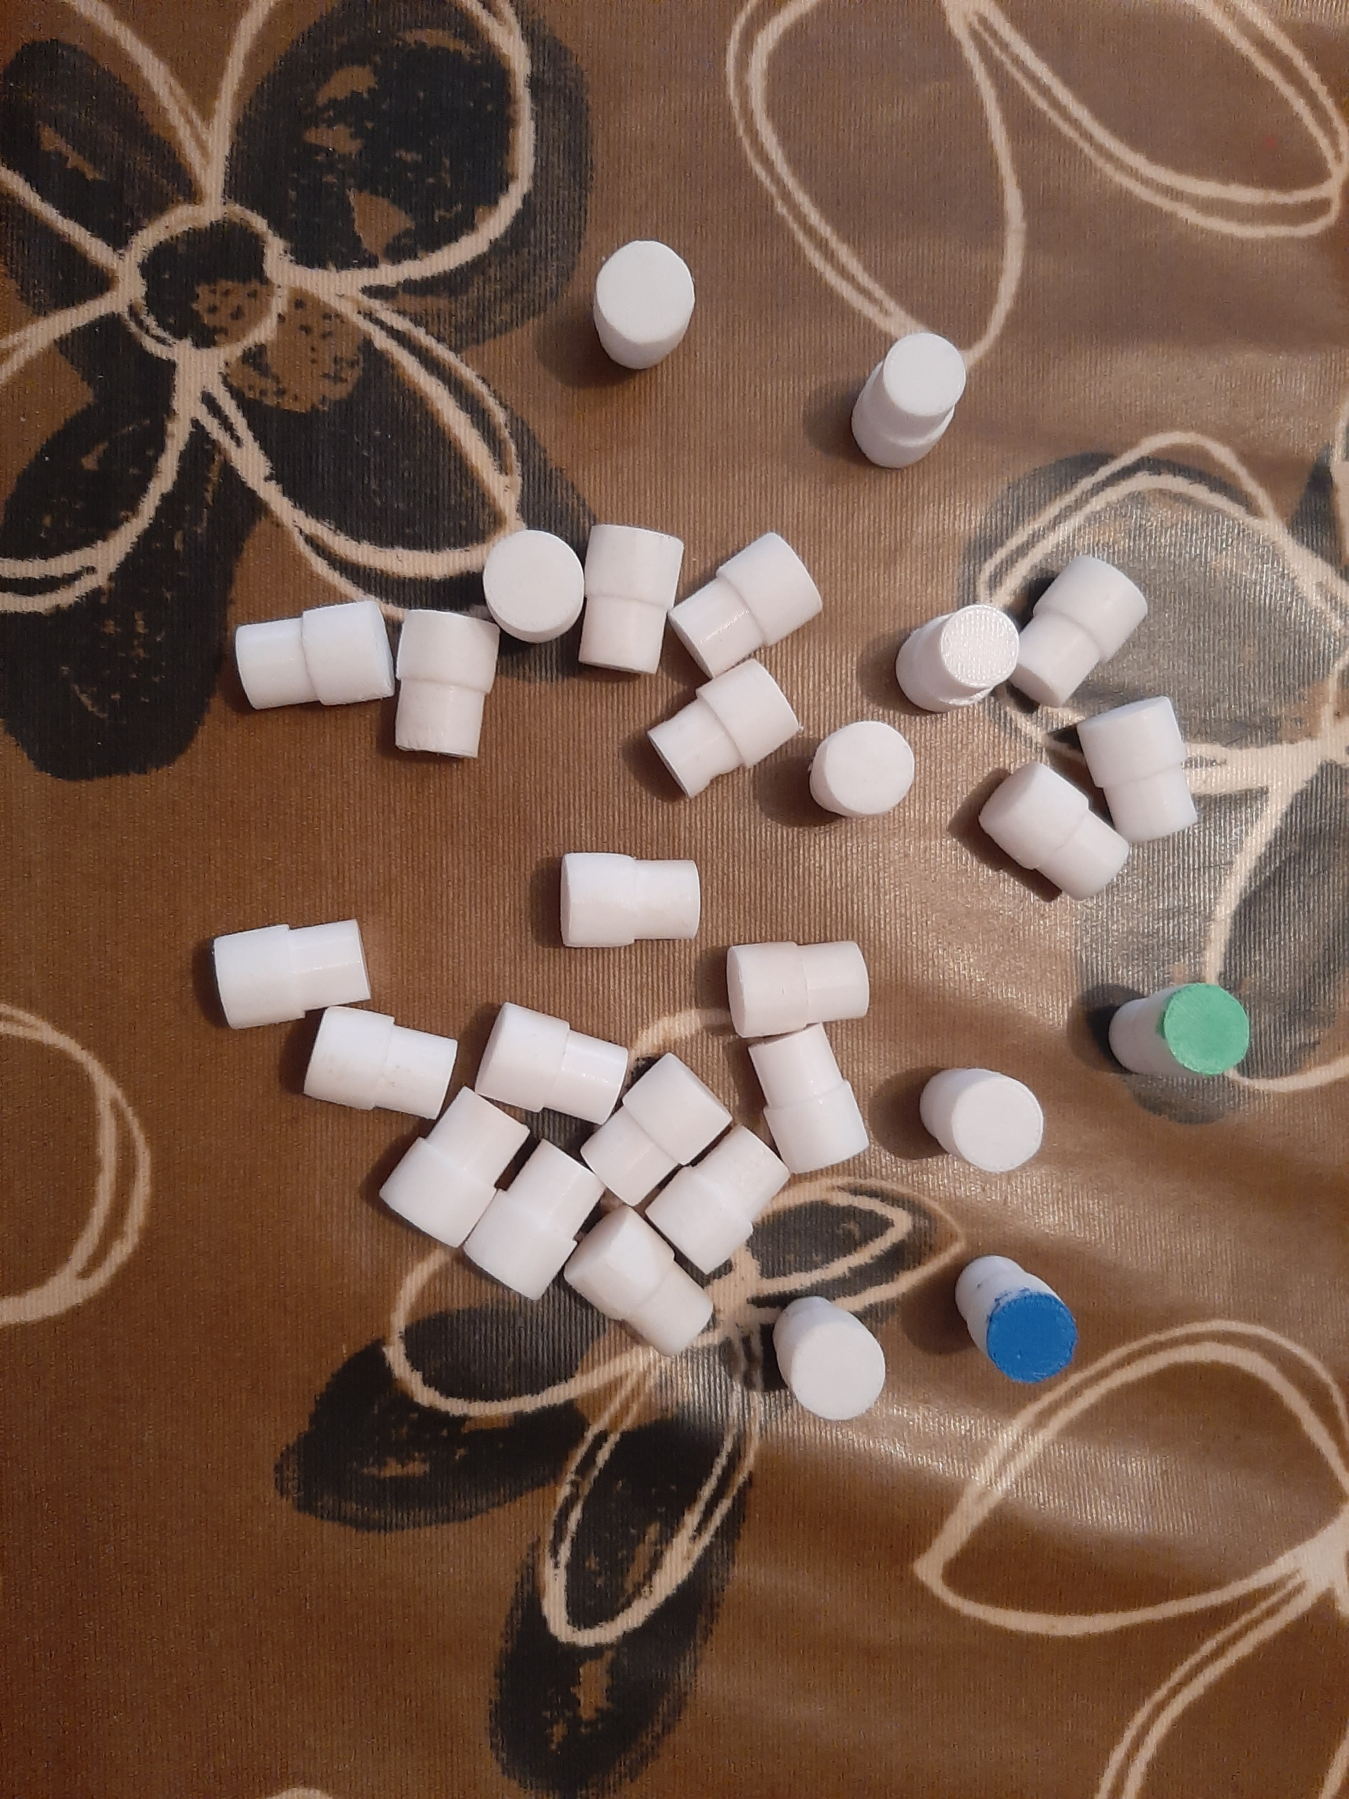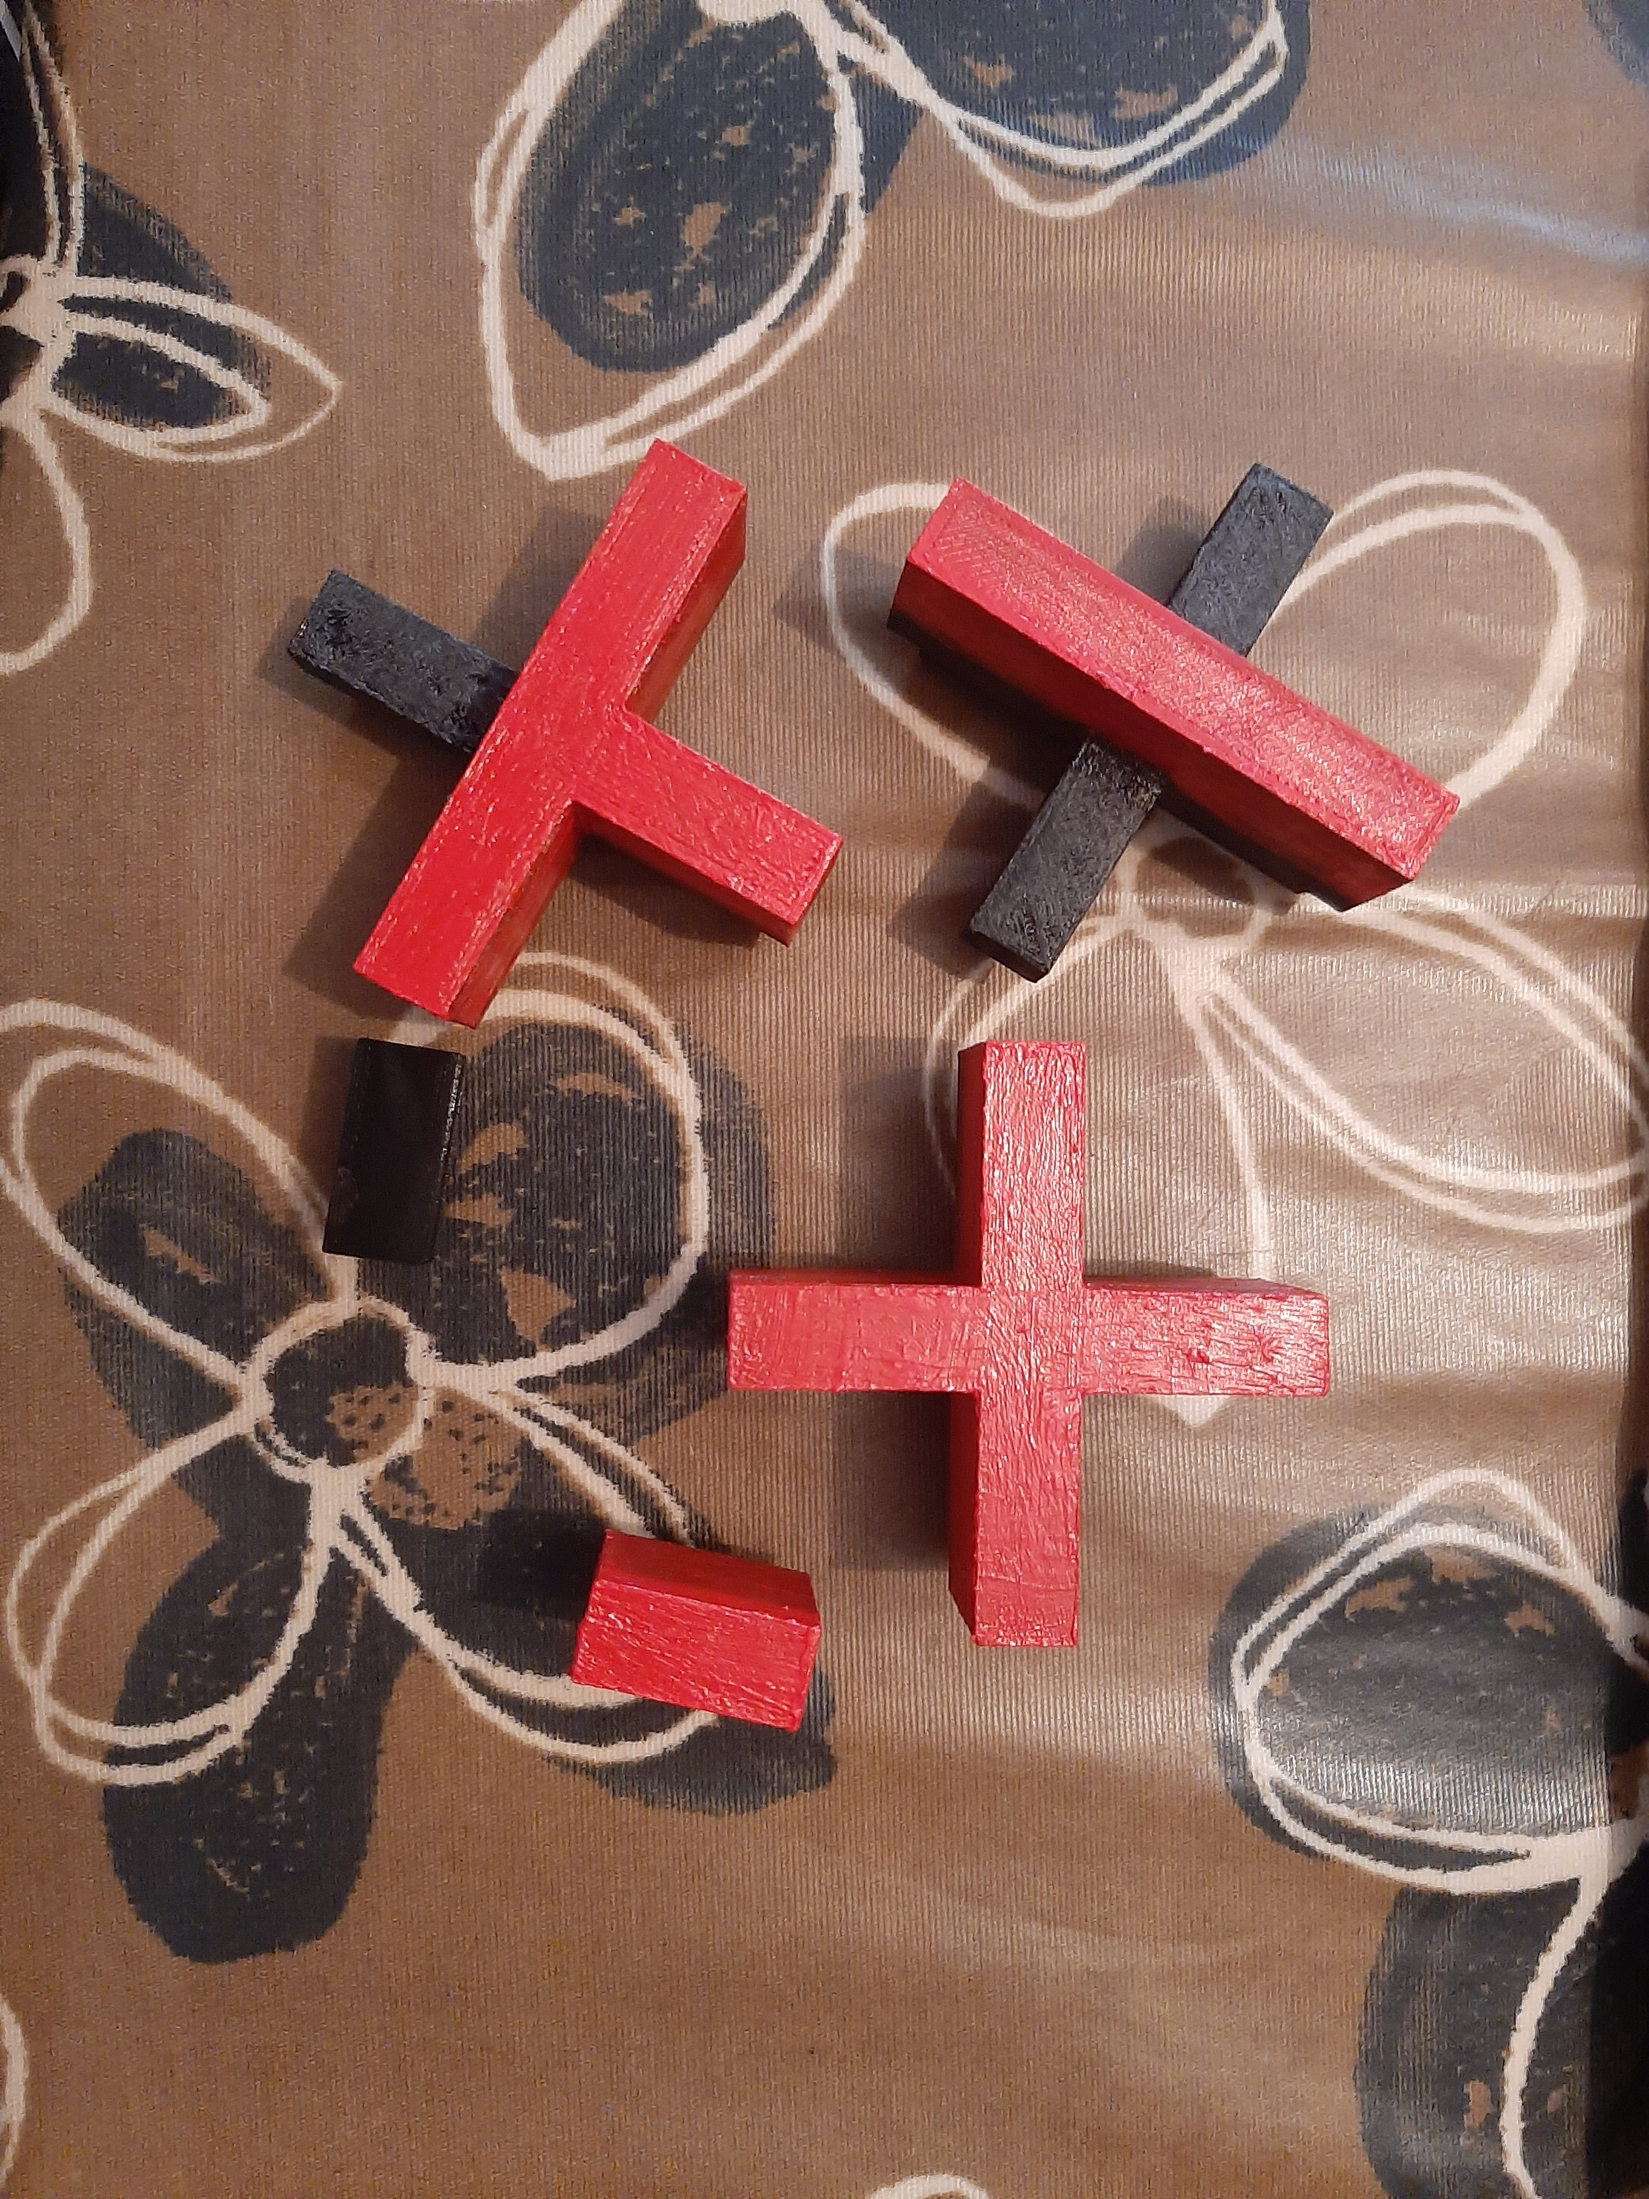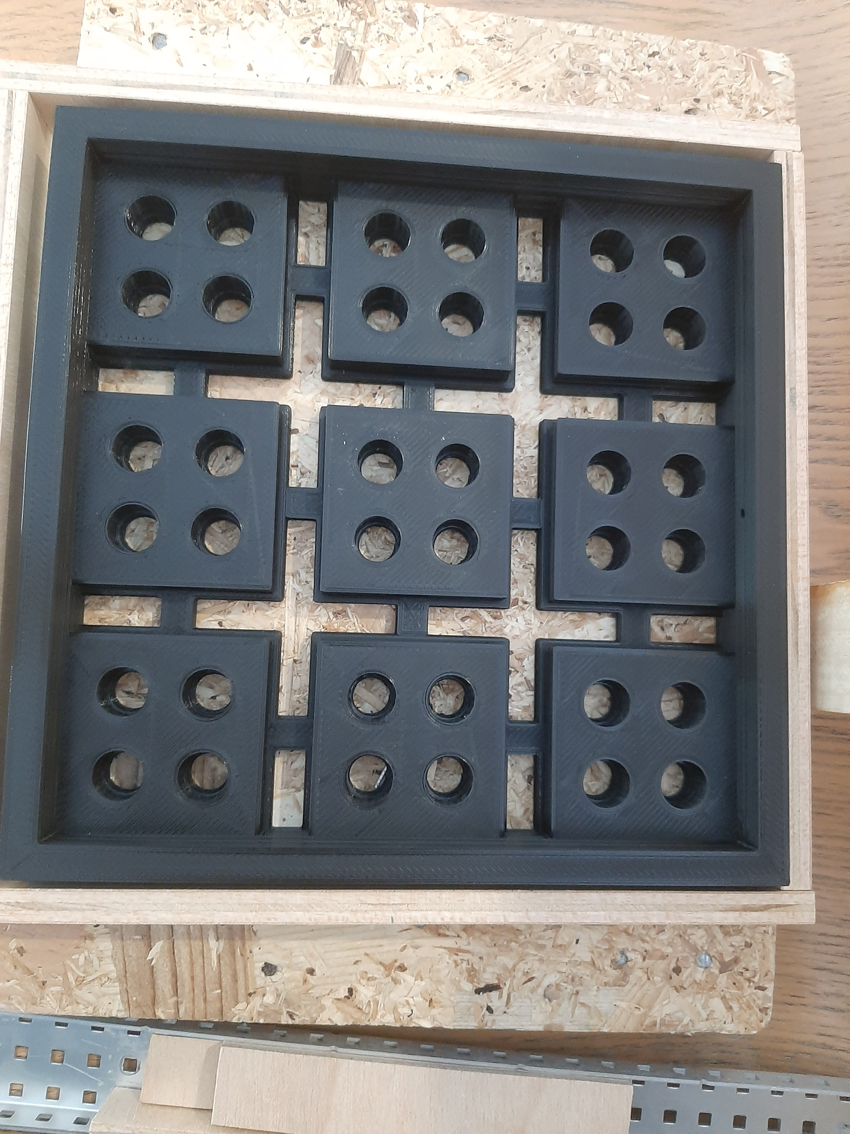- All the different types of walls and floors are also made so that we can change the shape and paths of the maze. Each piece has either floor, wall or both depending on the piece. On the one hand the floor parts are only as tall as the labyrinth base, so that the ball can go over these pieces without any struggle. On the other hand, the wall parts are made taller, so that the ball can not go pass them, giving the shape of the path that it needs to do in order to get to the end.

# Foreseen risks and contingency plan

|  |  |  |  |  |
| --- | --- | --- | --- | --- |
| **Risk #** | **Description** | **Probability** (High/  Medium/  Low) | **Impact** (High/  Medium/  Low**)** | **Contingency plan** |
| 1 | La visión por computador no siempre resuelve el laberinto  (encuentra camino, pero la bola se desvía / no encuentra camino) | High | Medium | Perfección milimétrica de los materiales y mejora de la calidad de imagen. |

References

This project has been inspired by the following Internet projects:

Original idea for the project by Antonio Álvarez: <https://www.youtube.com/watch?v=PMSr5L0SD24>

Tutorial - Usage of Joysticks with Arduino: <https://programarfacil.com/blog/arduino-blog/joystick-con-arduino/>

Tutorial - Usage of Servos with Arduino: <https://programarfacil.com/blog/arduino-blog/servomotor-con-arduino/>

Tutorial - Send data from Arduino to Raspberry (Serial connection): <https://www.youtube.com/watch?v=-3swby4ryU4>